**Analytical SQL Use Case**

**Name:** Hossam Smesm

**Track:** Data Analytics-Smart

**Q1**

* Top 5 countries by number of orders

SELECT distinct country,

count(invoice_no) over(partition by country ) total_orders

from online_retail

order by 2 desc

limit 5;

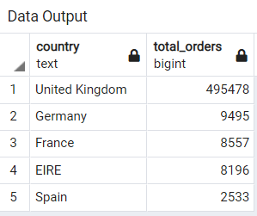

* Most popular product for each country

with t1 as (select distinct(country),

first_value(stock_code)over(partition by country

order by tot desc )as most_saled_prod

from (

select country,stock_code,sum(unit_price)over(partition by customer_id)::numeric(10,2)as tot from online_retail

)a

)

select * from t1;

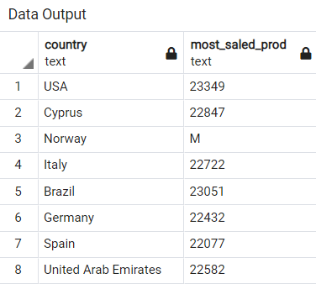

* **Total sales for each month sorted from most sales to lowest sales**

Select

distinct (inv_date),

Sum(total_sales)over(partition by inv_date, 'Month')::numeric(10) AS TOT_SALE_MONTHLY

from (

select

TO_CHAR(to_date(invoice_date,'mm/dd/yy'), 'Month')as inv_date,

(unit_price*quantity) as total_sales

from online_retail

)a

order by 2 desc;

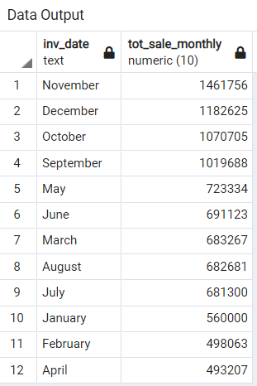

* **The country with the highest sales each year**

**select**

**distinct (inv_date),**

**first_value(country) over(partition by inv_date order by total_sales desc )**

**from (**

**select**

**country,**

**TO_CHAR(to_date(invoice_date,'mm/dd/yy'), 'YYYY')as inv_date,**

**(unit_price*quantity) as total_sales**

**from online_retail**

**)a;**

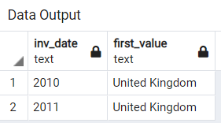

* **Number of orders per quarter over all years**

**Select**

**distinct (inv_date),**

**count(invoice_no)over(partition by inv_date) AS Tot_Orders_Quartarly**

**from (**

**select**

**invoice_no,**

**TO_CHAR(to_date(invoice_date,'mm/dd/yy'), 'Q')as inv_date**

**from online_retail**

**)a**

**order by 2 desc;**

